**Man Command**

[22A91A05G2@Linux ~]$ man who

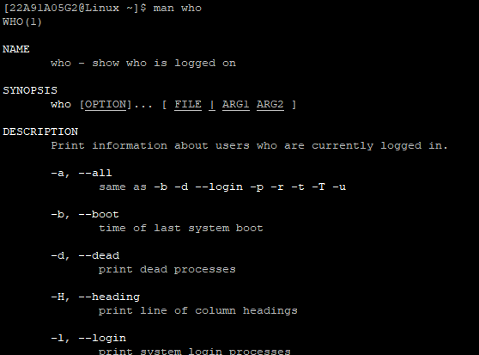

**WHO Command:**

[22A91A05G2@Linux ~]$ who

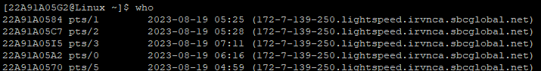

**Cat Command:**

[22A91A05G2@Linux ~]$ cat >>pokemon

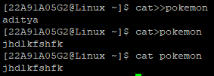

**Mkdir Command**

[22A91A05G2@Linux ~]$ mkdir exp1



**Cd Command**

[22A91A05G2@Linux ~]$ cd kranthi



**Rmdir Command**

[22A91A05G2@Linux ~]$ rmdir fire



**Ls Command**

[22A91A05G2@Linux ~]$ ls



**Cp Command**

[22A91A05G2@Linux ~]$ cp 5bex aditya.txt

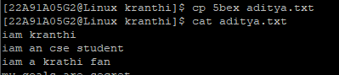

**Rm Command**

[22A91A05G2@Linux ~]$ rm aditya.txt



**Mv Command**

[22A91A05G2@Linux ~]$ mv 5bex swap

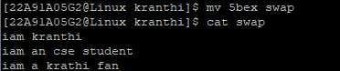

**Echo Command**

[22A91A05G2@Linux ~]$ echo “iam kranthi”



**More Command**

[22A91A05G2@Linux ~]$ more

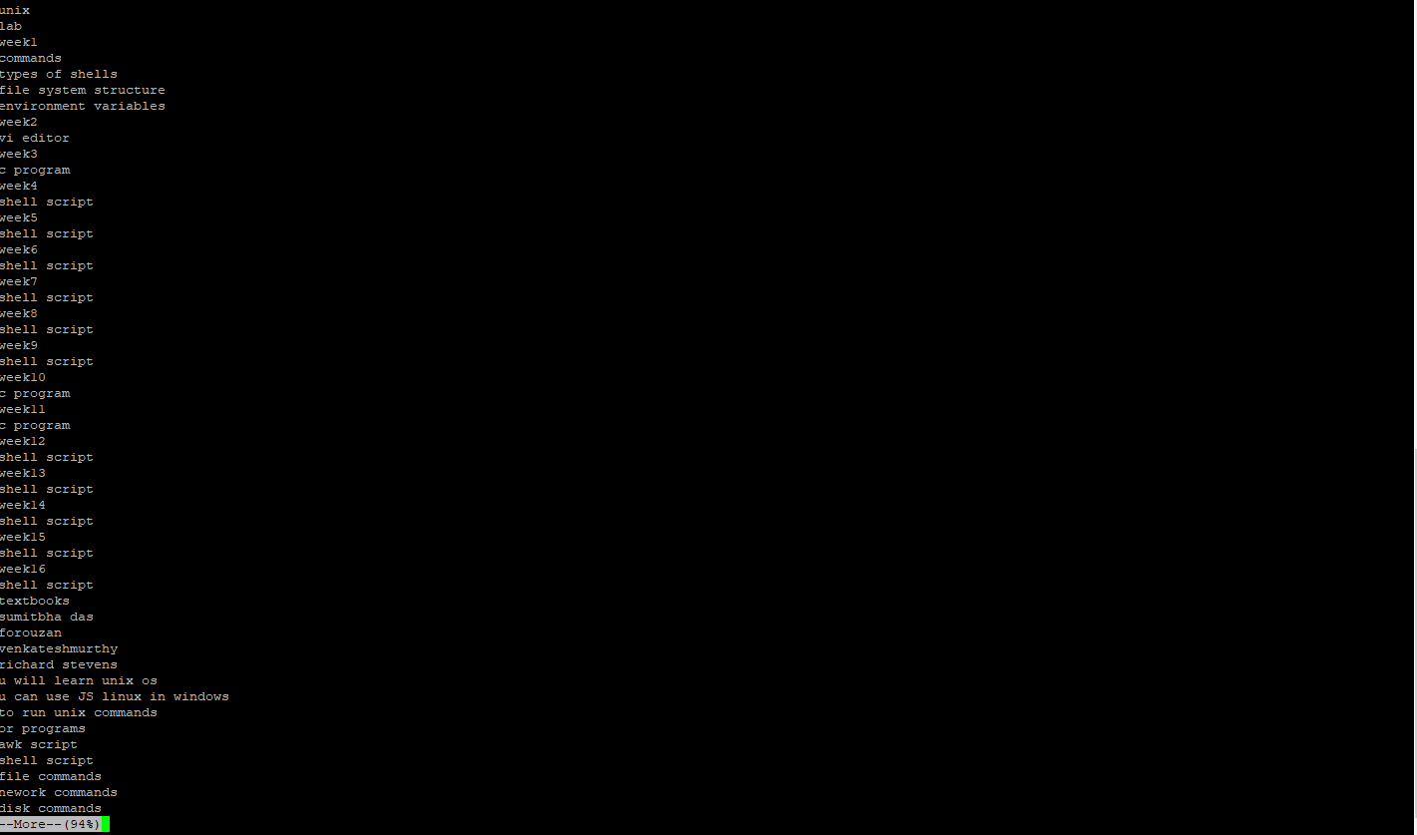

**Date Command**

[22A91A05G2@Linux ~]$ date

**Screenshot 2023-08-18 072248.png**

**Cal Command**

[22A91A05G2@Linux ~]$ cal 8

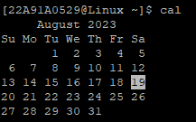

**Time Command**

[22A91A05G2@Linux ~]$ time

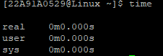

**Kill Command**

The kill processes simply pass the process id to the kill command.

[22A91A05G2@Linux ~]$ kill 4529

**History Command**

[22A91A05G2@Linux ~]$ history

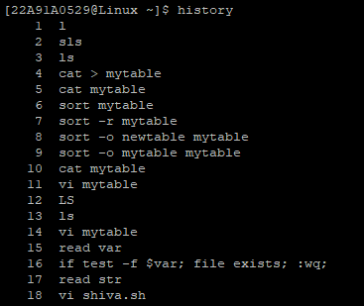

**Pwd Command**

[22A91A05G2@Linux ~]$ pwd

**Screenshot 2023-08-18 072852.png**

**Chomd Command**

[22A91A05G2@Linux ~]$ chmod 777 shiva.txt

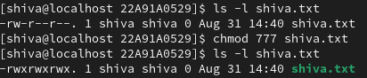

1. **Creating a Table:**

[22A91A05G2@Linux ~]$ cat >> mytable

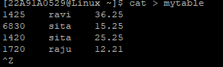

**b) Displaying file**

[22A91A05G2@Linux ~]$ cat mytable

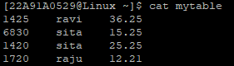

**c) Vi Command**

22A91A05G2@Linux ~]$ vi mytable

Screenshot 2023-08-18 061438.png

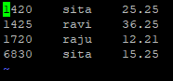

**d) Sorted table:**

22A91A05G2@Linux ~]$ sort mytable

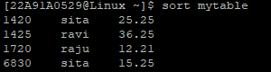

**e) Sort in reverse order :**

22A91A05G2@Linux ~]$ sort -r mytable

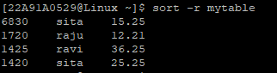

**e) Sort using new file:**

22A91A05G2@Linux ~]$ sort -o mytable newtable

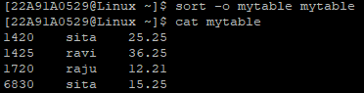

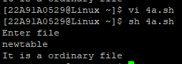

Screenshot 2023-08-18 073435.png